Net 1060 Introduction to Networks Lab: # 16.4.6

Name:

Follow the instructions down below for the lab itself. For this lab, all answers need to be in blue font. For the questions right below, answer in complete sentences. Ensure you paste the screen shot of your score page at the bottom of the document. Even if this does not let you see your grade, still take a screen shot of the score page showing congratulations “your name” you have completed the exercise is pasted at the bottom of this document. You will then need to upload both this word document and your packet tracer file to the assignments link within Netacad. Let the instructor know if you have any questions.

Lab Analysis Report

1. Using complete sentences summarize work you completed during the lab.
In this lab I configured device security for all the devices in the network. First, I did basic configurations. Then, I added encryption for all passwords. Then, I configured the IP addresses and default gateways. Then, I generated a crypto key. Finally, I configured ssh access.

2. Using complete sentences describe what you learned from the lab. Hint; look at the lab objectives listed at the top of the lab section.
In this lab, I learned more about the security measures you can add to routers and switches. I learned the commands to add encryption and generate a crypto key. I learned how to disable dns. I also learned how to enable ssh.

Problems Encountered

1. Using complete sentences describe any problem(s) experienced during lab.
I didn’t experience any problems.

2. Using complete sentences describe how you solved your problem(s).

3. Using complete sentences explain if you needed any assistance with the lab; then list what you learned from that assistance.

Packet Tracer - Configure Secure Passwords and SSH

Addressing Table
Device | Interface | IP Address | Subnet Mask | Default Gateway
RTA | G0/0 | 172.16.1.1 | 255.255.255.0 | N/A
PCA | NIC | 172.16.1.10 | 255.255.255.0 | 172.16.1.1
SW1 | VLAN 1 | 172.16.1.2 | 255.255.255.0 | 172.16.1.1

Scenario
The network administrator has asked you to prepare RTA and SW1 for deployment. Before they can be connected to the network, security measures must be enabled.

Intructions

Configure Basic Security on the Router
Open a command prompt
    - Configure IP addressing on PCA according to the Addressing Table.
Close a command prompt
Open configuration window
    - Console into RTA from the Terminal on PCA.
    - Configure the hostname as RTA.
    - Configure IP addressing on RTA and enable the interface.
    - Encrypt all plaintext passwords.
RTA(config)# service password-encryption
    - Set the minimum password length to 10.
RTA(config)# security password min-length 10
    - Set a strong secret password of your choosing. Note: Choose a password that you will remember, or you will need to reset the activity if you are locked out of the device.
    - Disable DNS lookup.
RTA(config)# no ip domain-lookup
    - Set the domain name to CCNA.com (case-sensitive for scoring in PT).
RTA(config)# ip domain-name CCNA.com
    - Create a user of your choosing with a strong encrypted password.
RTA(config)# username any_user secret any_password
    - Generate 1024-bit RSA keys.
Note: In Packet Tracer, enter the crypto key generate rsa command and press Enter to continue.
RTA(config)# crypto key generate rsa
The name for the keys will be: RTA.CCNA.com
Choose the size of the key modulus in the range of 360 to 2048 for your
General Purpose Keys. Choosing a key modulus greater than 512 may take
a few minutes.

How many bits in the modulus [512]: 1024
    - Block anyone for three minutes who fails to log in after four attempts within a two-minute period.
RTA(config)# login block-for 180 attempts 4 within 120
    - Configure all VTY lines for SSH access and use the local user profiles for authentication.
RTA(config)# line vty 0 4
RTA(config-line)# transport input ssh
RTA(config-line)# login local
    - Set the EXEC mode timeout to 6 minutes on the VTY lines.
RTA(config-line)# exec-timeout 6
    - Save the configuration to NVRAM.
Close configuration window
    - Access the command prompt on the desktop of PCA to establish an SSH connection to RTA.
Open a command prompt
C:\> ssh /?
Packet Tracer PC SSH
Usage: SSH -l username target
C:\>
Close a command prompt

Configure Basic Security on the Switch
Configure switch SW1 with corresponding security measures. Refer to the configuration steps on the router if you need additional assistance.
    - Click on SW1 and select the CLI tab.
Open a configuration window
    - Configure the hostname as SW1.
    - Configure IP addressing on SW1 VLAN1 and enable the interface.
    - Configure the default gateway address.
    - Disable all unused switch ports.
Note: On a switch it is a good security practice to disable unused ports. One method of doing this is to simply shut down each port with the ‘shutdown’ command. This would require accessing each port individually. There is a shortcut method for making modifications to several ports at once by using the interface range command. On SW1 all ports except FastEthernet0/1 and GigabitEthernet0/1 can be shutdown with the following command:
SW1(config)# interface range F0/2-24, G0/2
SW1(config-if-range)# shutdown
%LINK-5-CHANGED: Interface FastEthernet0/2, changed state to administratively down

%LINK-5-CHANGED: Interface FastEthernet0/3, changed state to administratively down
<Output omitted>
%LINK-5-CHANGED: Interface FastEthernet0/24, changed state to administratively down

%LINK-5-CHANGED: Interface GigabitEthernet0/2, changed state to administratively down
The command used the port range of 2-24 for the FastEthernet ports and then a single port range of GigabitEthernet0/2.
    - Encrypt all plaintext passwords.
    - Set a strong secret password of your choosing.
    - Disable DNS lookup.
    - Set the domain name to CCNA.com (case-sensitive for scoring in PT).
    - Create a user of your choosing with a strong encrypted password.
    - Generate 1024-bit RSA keys.
    - Configure all VTY lines for SSH access and use the local user profiles for authentication.
    - Set the EXEC mode timeout to 6 minutes on all VTY lines.
    - Save the configuration to NVRAM.
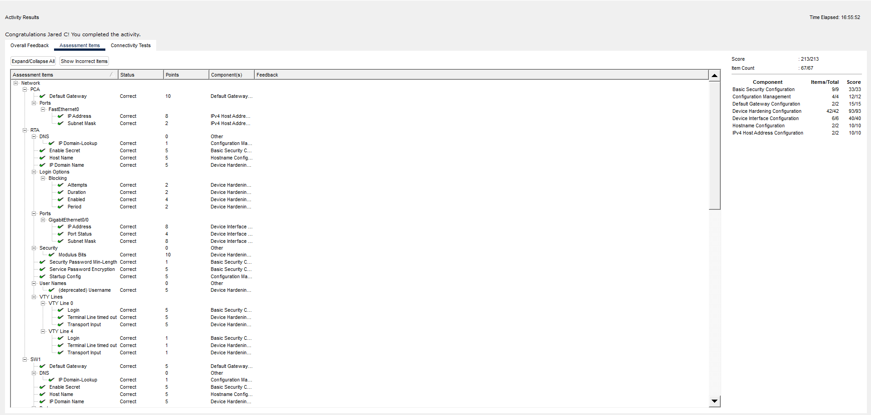
Close a configuration window
End of document

